**EECS 118**

**Knowledge Engineering and Software Engineering**

**Fall 2018**

**Term Project**

**Option II: A Geometry Problem Solver**

**Project Supplement**

**Problem Set S**

You are required to create a separate solver for each one of the following problems. Please use Python 3.5 or above as your programming language for the solver program.

Assigned Problems:

1. A triangle and a circle have four intersection points:

The circle is tangent to two sides of the triangle, two other intersections are on the third side.

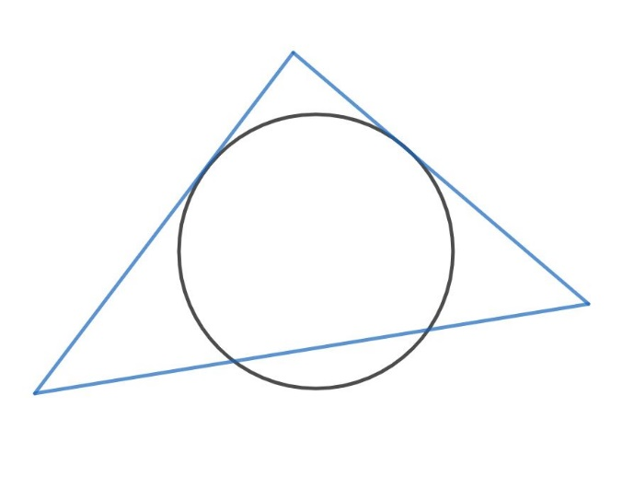

1. A line segment overlaps one side of a triangle:

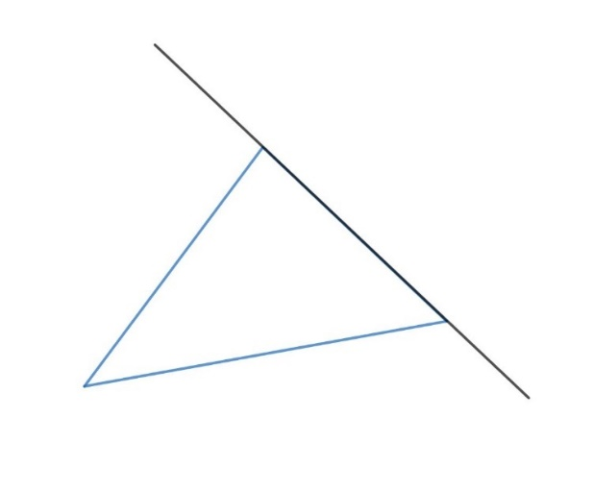

1. Two circles have two intersection points:

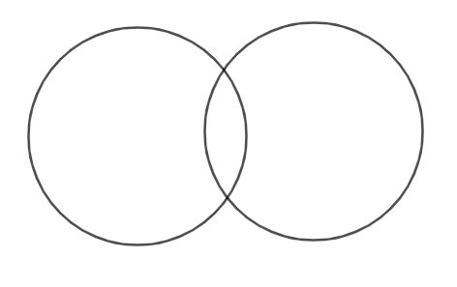

You are encouraged to draw your own diagrams according to the description. The diagrams above are only for your reference, you need to consider all cases as long as they meet the description. Please also consider boundary cases.

Extra Credits:

Instead of creating solvers for the above problems, design a solver that can solve any one circle and one triangle problems.

Resources:

[Learn Python in 60 Minutes from Java](https://www.youtube.com/watch?v=xLovcfIugy8)

[How to solve a triangle](https://en.wikipedia.org/wiki/Solution_of_triangles#Solving_plane_triangles): You can start here.

[Review on Circles](https://www.onlinemathlearning.com/circles.html): In case you need a review on circles.

[Law of Sines--Ambiguous Case](http://jwilson.coe.uga.edu/EMT668/EMAT6680.2001/Mealor/EMAT%206700/law%20of%20sines/Law%20of%20Sines%20ambiguous%20case/lawofsinesambiguouscase.html): A special case.

[Single Triangle Calculator](https://www.triangle-calculator.com/): An online demo of single triangle problem solver.

[SymPy Geometry Module](https://docs.sympy.org/latest/modules/geometry/index.html): SymPy is a Python library, you may find its geometry module helpful.